**ASSIGNMENT 5.1**

**on**

**Introduction to Data Pipelines**

**Submitted by:**

**Haseebullah Shaikh (2303.KHI.DEG.015)**

**and**

**Faiza Gulzar Ahmed (2303.khi.deg.001)**

**Dated:** 16th May 2023

**Solution:**

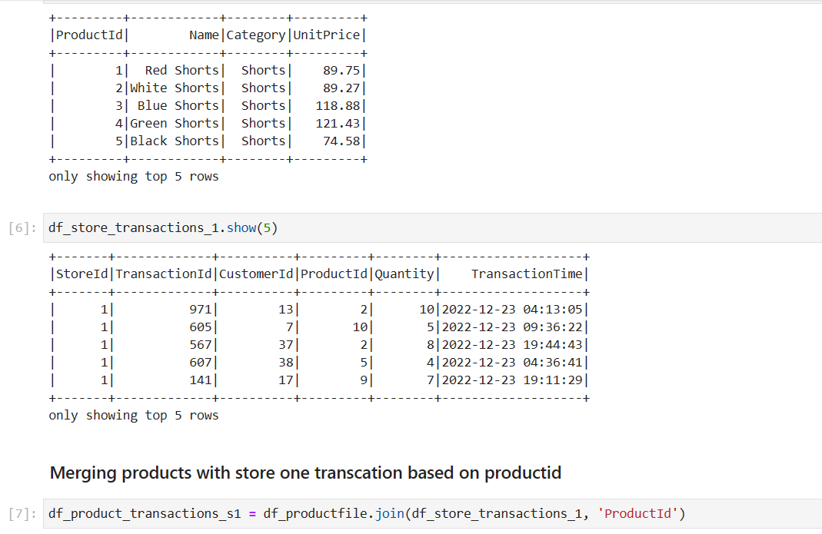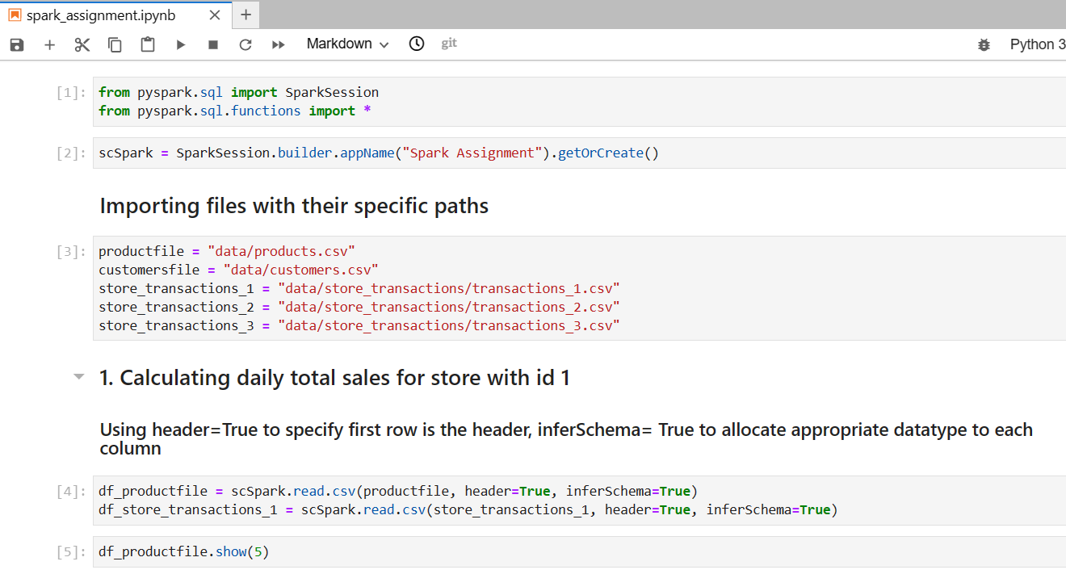

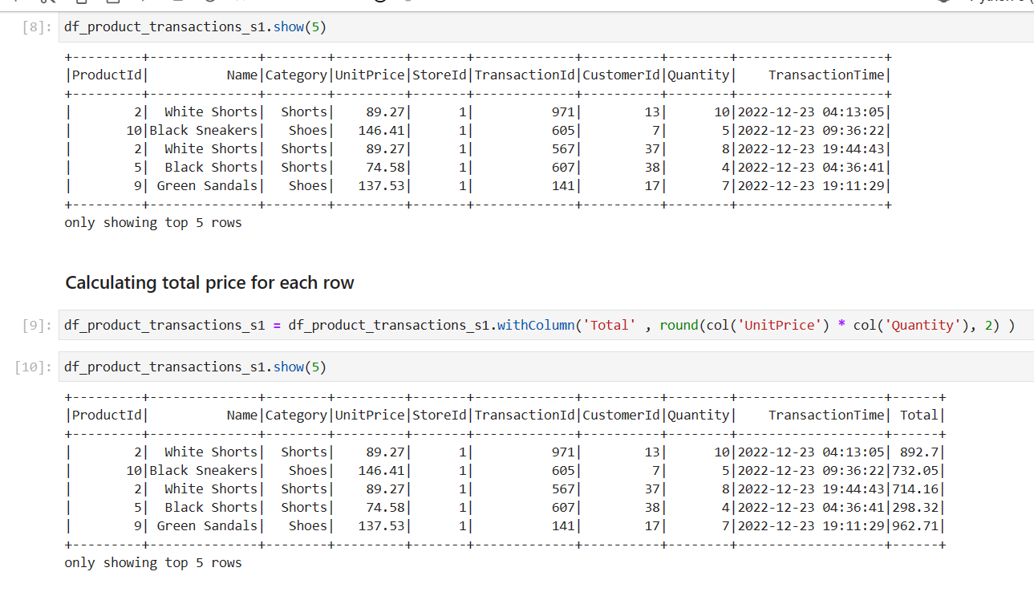

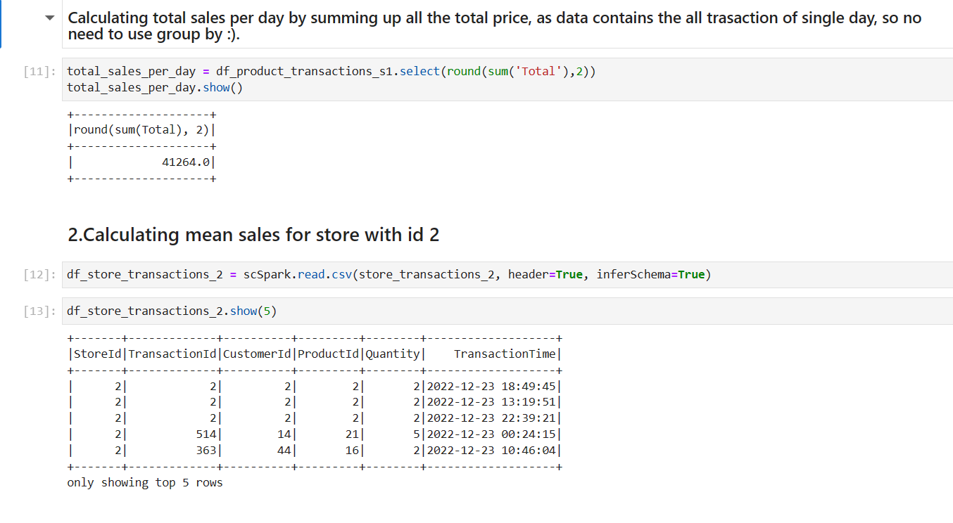

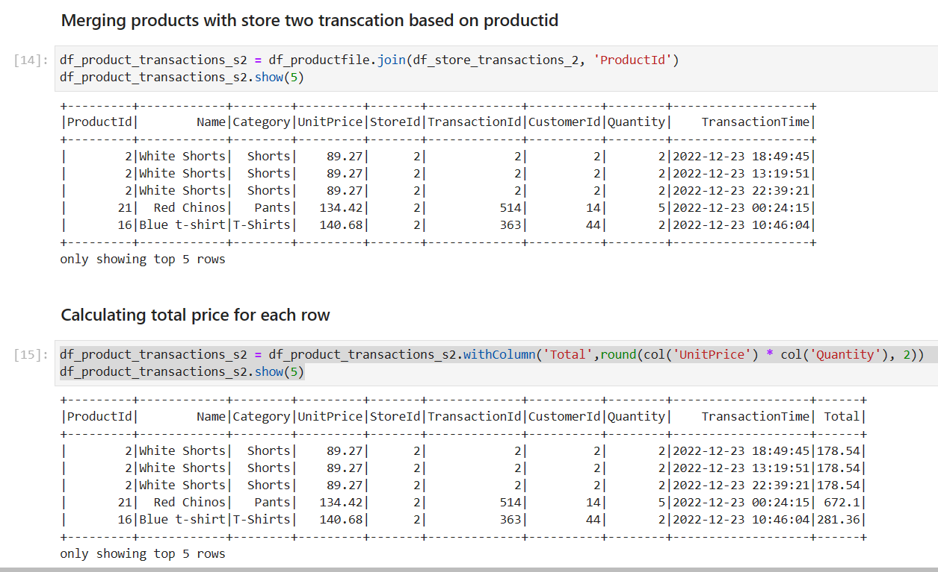

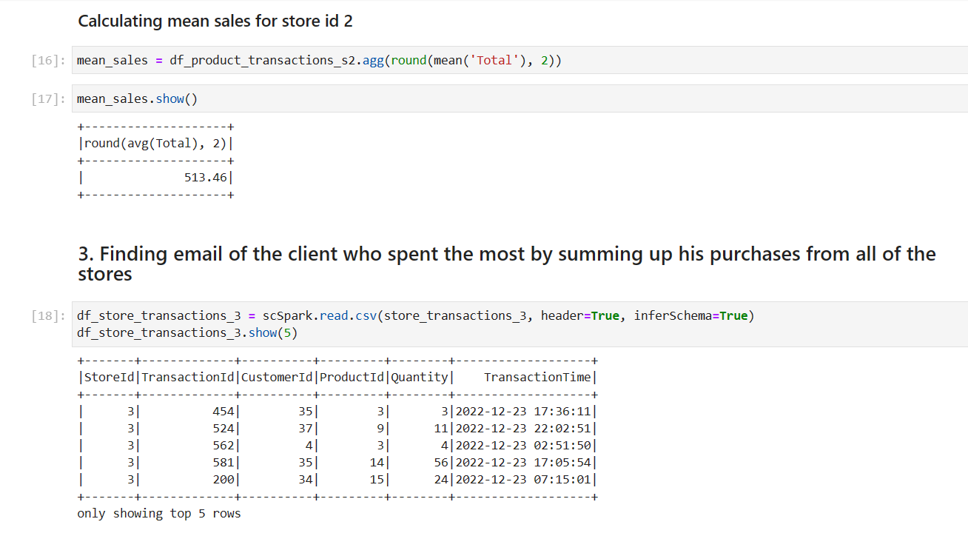**f**

**.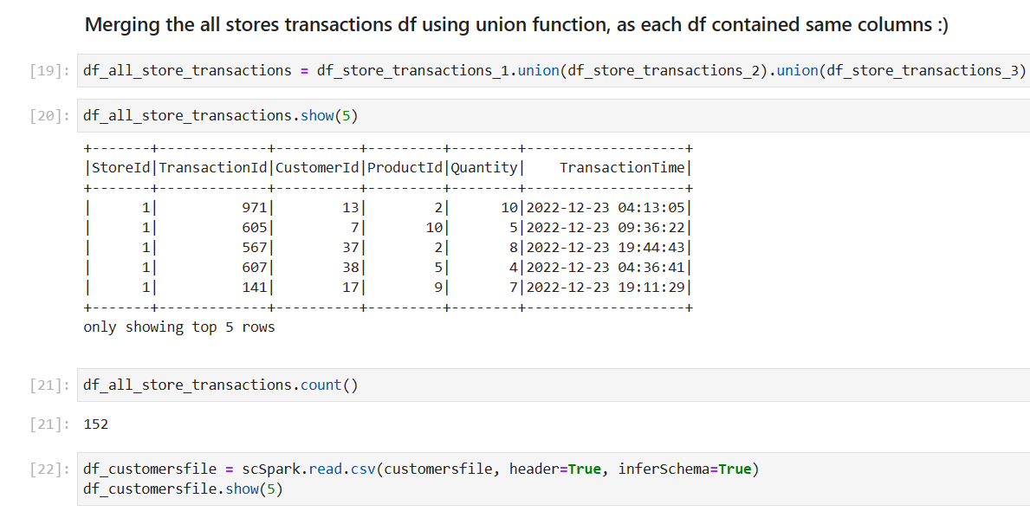.**

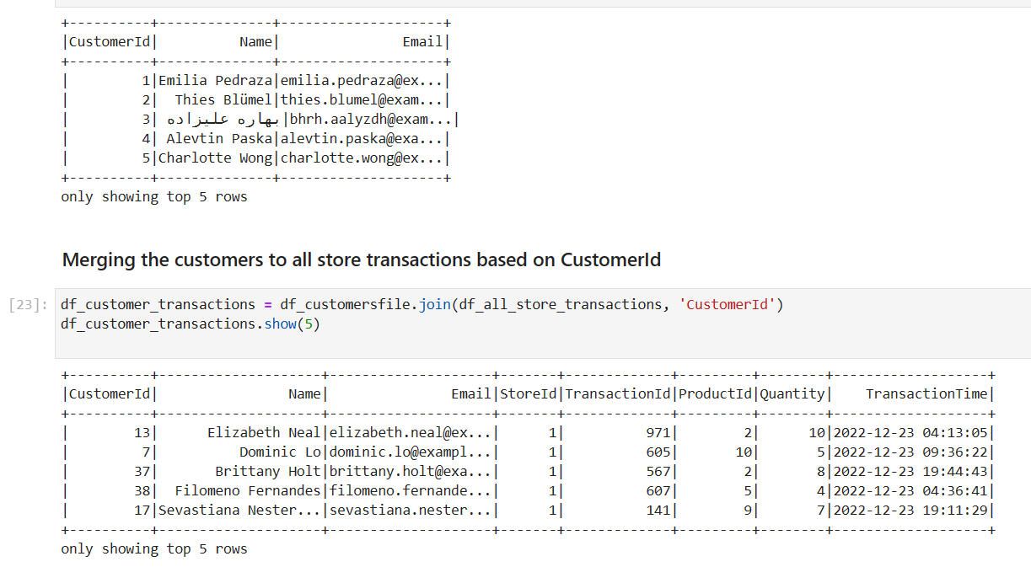

**.**

**....**

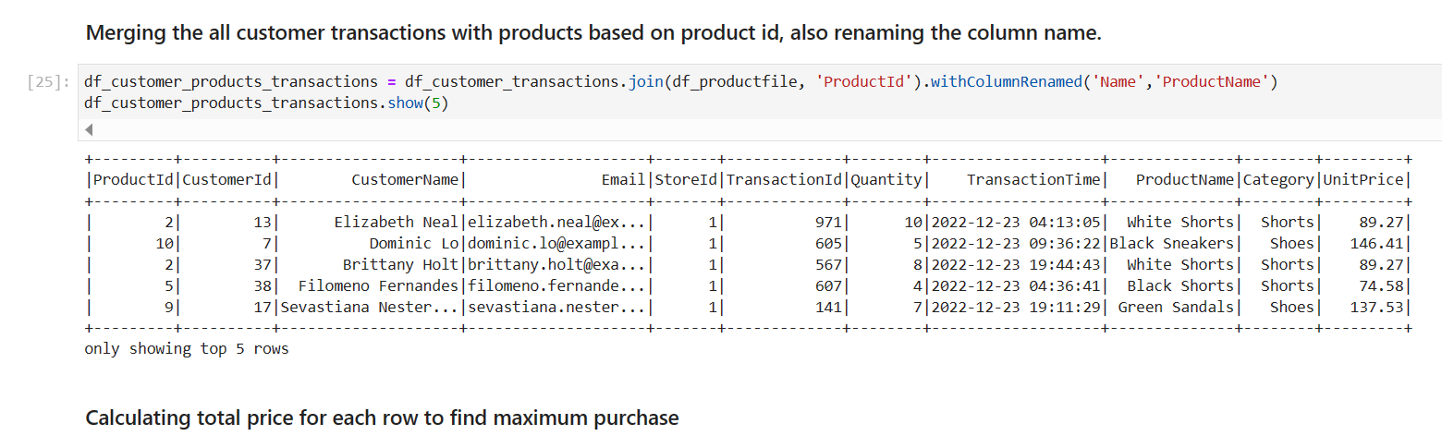**.**

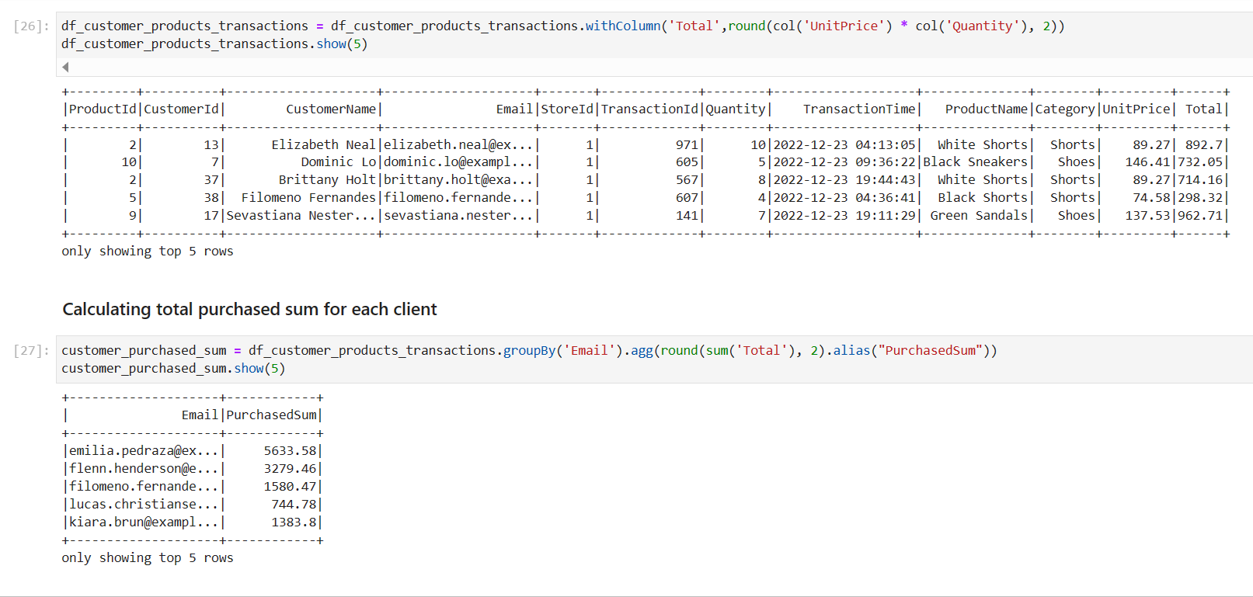

**.**

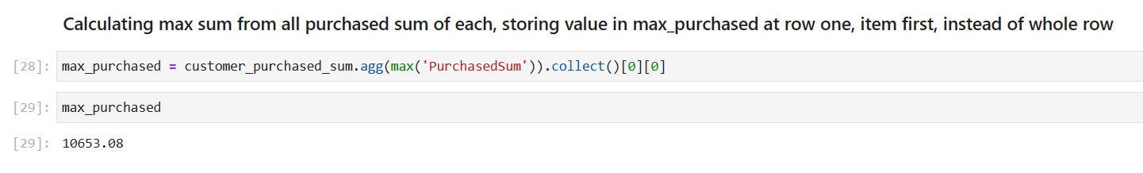**..**

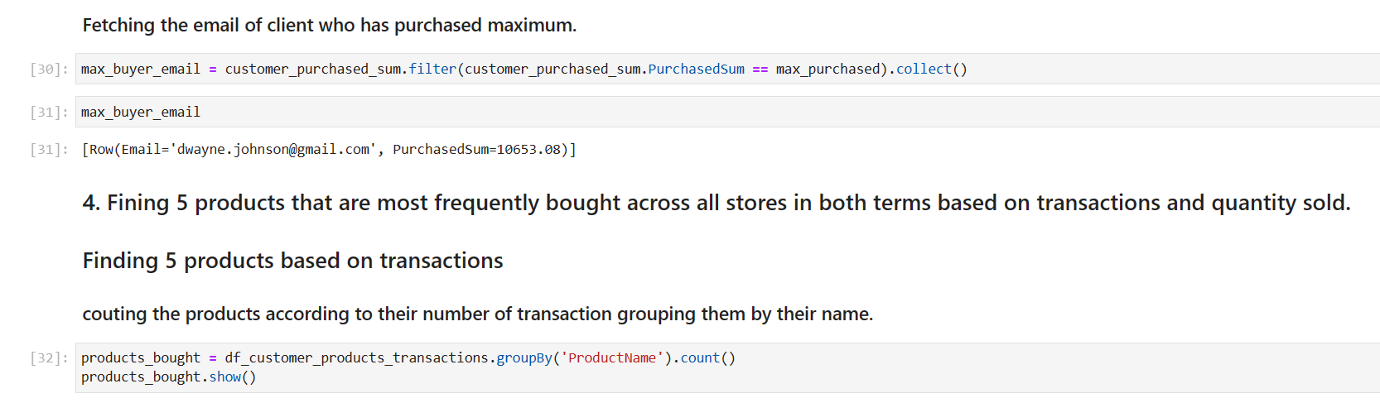

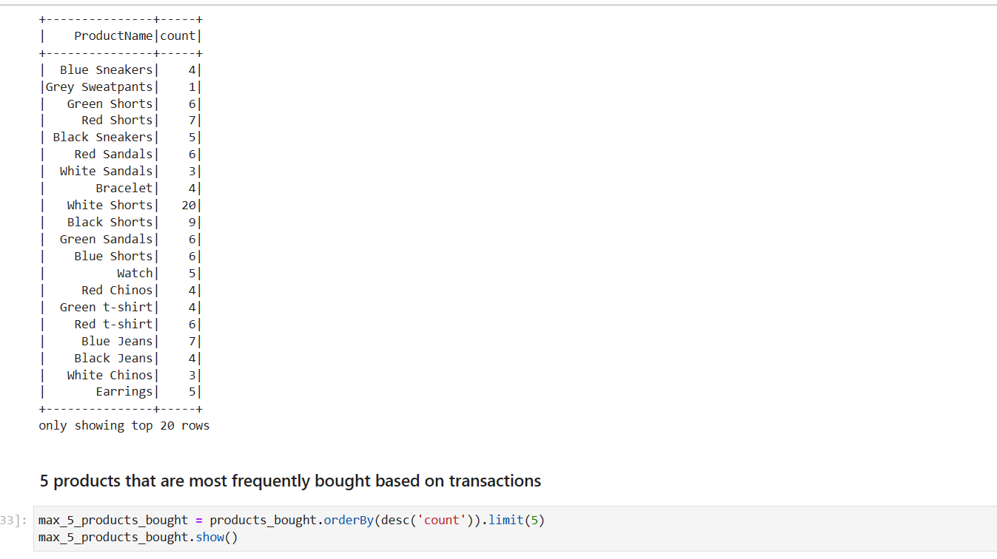**..**

**.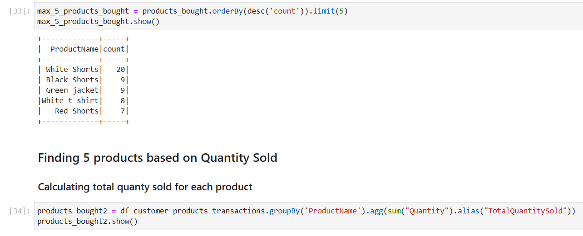..**

**.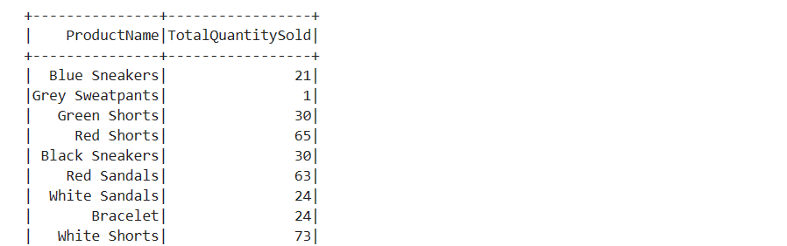...**

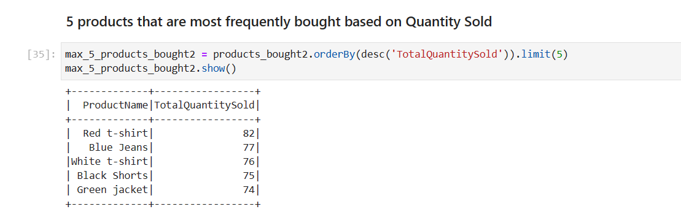**..**

**The End ☺**